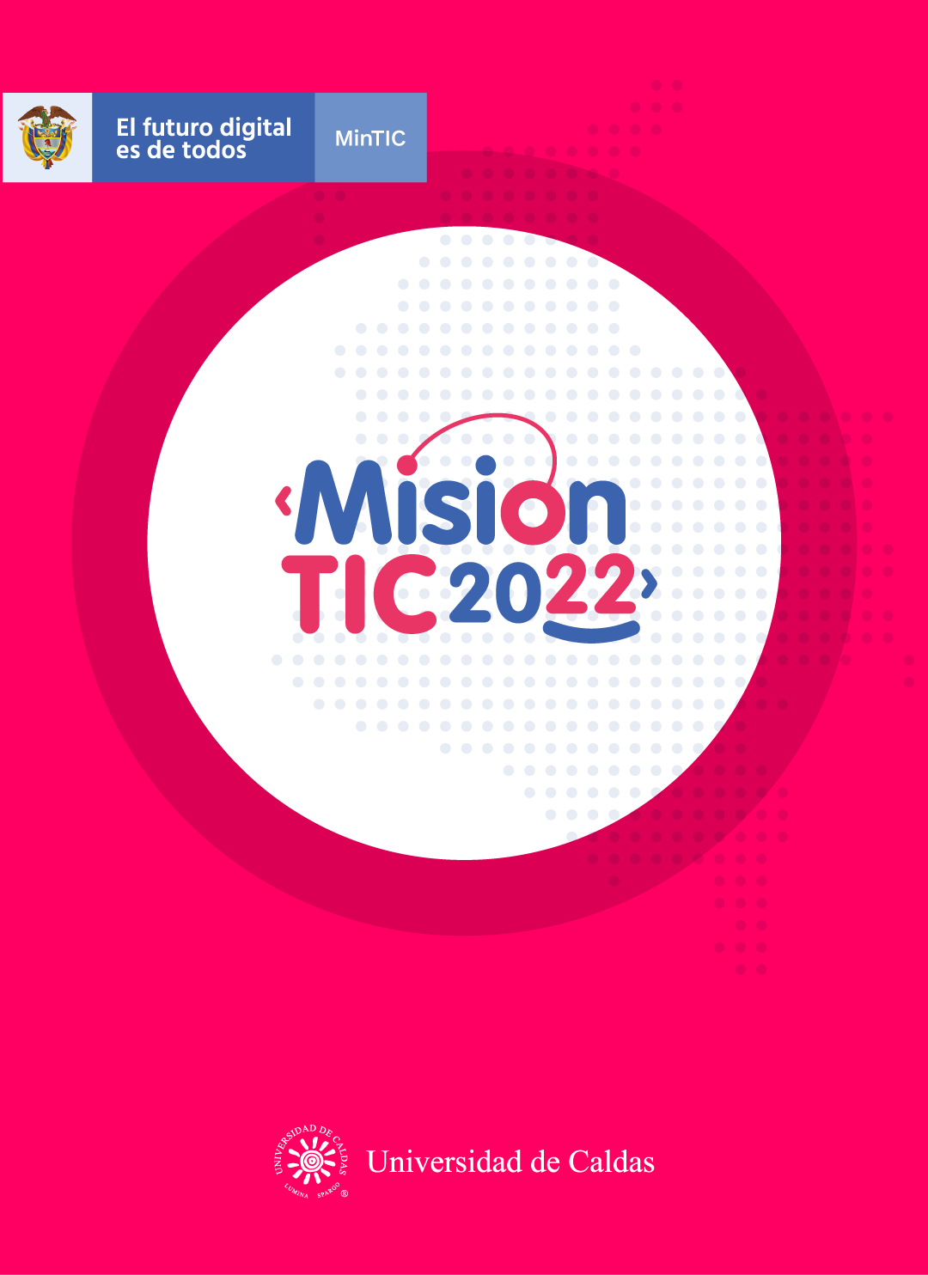

**Usability and Accessibility of computer programs**

**Worksheet 12.1**

**Vocabulary part**

**Complete the sentences using true sentences:**

* A product is accessible if striking ________________________________
* User feedback helps to improvement ____________________________
* Developer is a program’s _______________________________________
* A bug is developing common ___________________________________
* When you create an app you cannot predict in advance _______________

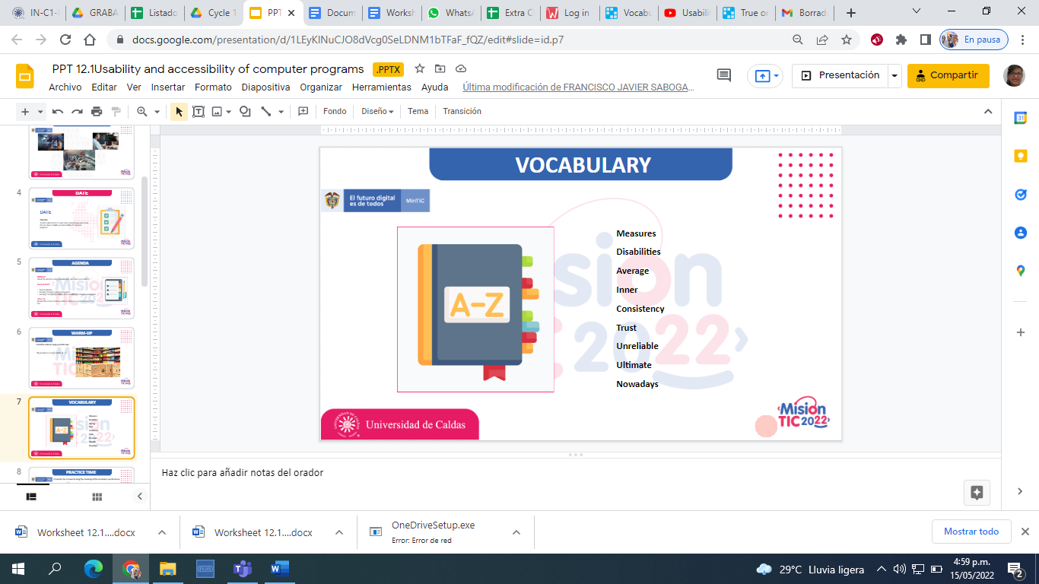

[**https://wordwall.net/resource/17509943/true-or-false-vocabulary**](https://wordwall.net/resource/17509943/true-or-false-vocabulary)

**Extra activity: Complete the crossword using the meaning of the vocabulary words (Favor realizar mejor este crucigrama en este link y pegar la imagen)**

[**https://wordwall.net/resource/17350528/vocabulary-session-12**](https://wordwall.net/resource/17350528/vocabulary-session-12)

**Cross Word**

|  |  |  |  |  |  |  |  |  |  |  |  |  |  |  |  |  |  |  |  |  |  |  |  |
| --- | --- | --- | --- | --- | --- | --- | --- | --- | --- | --- | --- | --- | --- | --- | --- | --- | --- | --- | --- | --- | --- | --- | --- |
|  |  | |  |  |  | |  |  |  |  |  |  |  |  |  |  |  |  |  |  |  |  |  |
|  |  | |  |  | |  |  |  |  | 2 |  |  |  |  |  |  |  |  |  |  |  |  |  |
|  |  | | 1 |  |  | |  |  |  |  |  |  |  |  |  |  |  |  |  |  |  |  |  |
|  |  | |  |  |  | |  |  |  |  |  |  |  |  |  |  |  |  |  |  |  |  |  |
|  |  | |  | 3 |  | |  |  |  |  |  |  |  |  |  |  |  |  |  |  |  |  |  |
|  | | 8 |  |  |  | |  |  |  |  |  | 4 |  |  |  |  |  |  |  |  |  | 9 |  |
|  |  | |  |  |  | |  |  |  |  |  |  |  |  |  |  |  |  |  |  |  |  |  |
|  |  | |  |  |  | |  |  |  |  |  |  |  |  |  |  |  |  |  |  |  |  |  |
|  |  | |  |  |  | |  |  |  |  |  |  |  |  |  |  |  | 7 |  |  |  |  |  |
|  |  | |  |  |  | |  |  |  |  |  | 6 |  |  | 5 |  |  |  |  |  |  |  |  |
|  |  | |  |  |  | |  |  |  |  |  |  |  |  |  |  |  |  |  |  |  |  |  |
|  |  | |  |  |  | |  |  |  |  |  |  |  |  |  |  |  |  |  |  |  |  |  |
|  |  | |  |  |  | |  |  |  |  |  |  |  |  |  |  |  |  |  |  |  |  |  |
|  |  | |  |  |  | |  |  |  |  |  |  |  |  |  |  |  |  |  |  |  |  |  |
|  |  | |  |  |  | |  |  |  |  |  |  |  |  |  |  |  |  |  |  |  |  |  |
|  |  | |  |  |  | |  |  |  |  |  |  |  |  |  |  |  |  |  |  |  |  |  |
|  |  | |  |  |  | |  |  |  |  |  |  |  |  |  |  |  |  |  |  |  |  |  |

**Across**

1. A standard unit used to express the size, amount, or degree of something.

8 Consistent behavior or treatment.

6 A physical or mental condition that limits a person's movements, senses, or activities.

**Down**

1. Believe in the reliability, truth, or ability

3 Happening or occurring inside

4 At the present time, in contrast with the past.

5 A number that is calculated by adding quantities together and dividing the total by the number of quantities

7 Being or happening at the end of a process; final.

9 Not able to be relied upon.

**Worksheet 12.2**

**Read the text, then create a word cloud using the keywords you found in the text.**

**CONCEPTS OF USABILITY AND ACCESSIBILITY IN SOFTWARE DEVELOPMENT**

[**https://www.youtube.com/watch?v=DgOg97ic9vk**](https://www.youtube.com/watch?v=DgOg97ic9vk)

UNIVERSAL DESIGN

Usability and accessibility are two important concepts in the process of software development. Usability **measures** how easy it is to use a program, and accessibility measures how accessible a program is for people with different **disabilities**. Typically, programs are designed for the **average** user and do not consider all the possible characteristics of potential users. Ideally, developers should consider the principles of the “universal design” when creating a new product. Universal design means that absolutely everyone can use the final product. The application of universal design principles during product design has the potential to make products accessible to and usable by more consumers.

USABILITY TESTING

Many companies do usability testing to guarantee that the product is satisfactory for the users. This usability process is frequently done at different phases of product development. The objective of the usability testing is to make the product more efficient and attractive to users. Jakob Neilsen, one of the most visible proponents of usability processes, articulated five elements that comprise a definition of usability (Nielsen, 1996).

1. *Ease of use*. The user must be able to use the product in a simple form.
2. *Simplicity of learning*. The features of a product must have **inner** **consistency** and logic.
3. *Improved reliability*. When users can **trust** that they can use products as expected, satisfaction can increase.
4. *Reduction in errors*. Designers can reduce user errors. It is important for the developers to understand that the product can be culpable or **unreliable**. In this case, they can re-design it in a good way.
5. *Improved user satisfaction*. If user satisfaction is important for the developers, they should incorporate all the previous recommendations in the product. As a result, users will be happy to use it.

ACCESSIBILITY

Accessibility refers to creating products that are accessible for different kinds of people. Accessibility tests on new products are not very common, and when companies do this type of tests, they usually do them after usability testing. As a result, many products meet only minimum accessibility standards, but this doesn't mean that they are easy to use for all people.

For example, historically, people with disabilities are not included in the standard usability tests of many products because designers do not consider people with disabilities to be part of the **ultimate** users. However, **nowadays,** the population of people with disabilities grows, and it means that more and more products for them will be necessary.

**Worksheet 12.3**

**Answer these True or False questions to check your understanding of the text.**

1. Usability and Accessibility are two synonyms that mean the same. False
2. A universal design product is easy to use by all the people. True
3. The objective of usability testing is to make the product more attractive for the users. True
4. Accessibility test are very common in many companies. False
5. Companies often do not take people with disabilities into account when designing new products. True

**Read the text then create a word cloud using the key words you  found in the text.**

<https://wordart.com/login?next=/my-word-art>

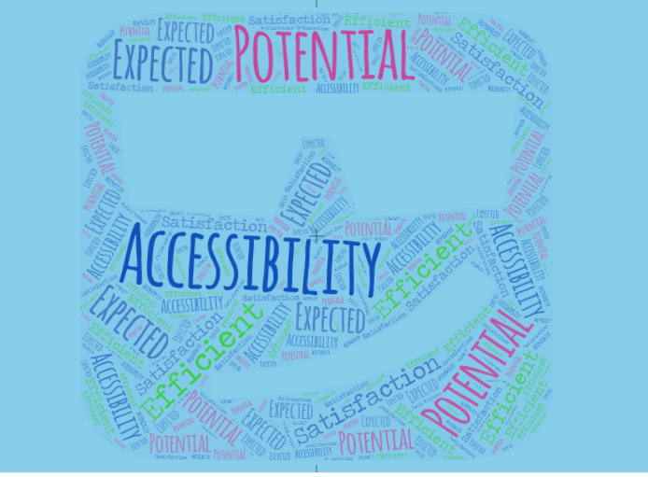

**Worksheet 12.4**

**Answer the following questions.**

1. Entiendo que es “usability”, “accessibility” y la diferencia entre ellos.

Si No Tal vez

1. Entiendo cómo buscar las palabras claves en un texto.

Si No Tal vez

1. Buscar las palabras claves en un texto me ayuda a identificar los conceptos principales del texto.

Si No Tal vez